



The **EPISTLES OF FAITH**

**FAITH UNITED CHURCH OF CHRIST**

628 Clermont Street

Antigo, Wisconsin 54409

Phone: 715-623-5717

Church E-Mail Address: [faithucc@frontier.com](mailto:faithucc@frontier.com)

Rev. Dr. Wes A. Jedras: [wjedras@hotmail.com](mailto:wjedras@hotmail.com)

Church Website: [www.antigofaithucc.org](http://www.antigofaithucc.org)

**Administrative Assistant:** Laurie Hackbarth

**Church Office Hours:** Monday Closed;

Tuesday through Thursday 8:30 AM - 2:30 PM; Friday - Closed

**Church Council Chair:** Sue Moseman

**SUNDAY SCHEDULE**

**Worship:** 10:30 a.m.

***You are invited - Bring a friend!***

A

A



2025

**A Story from Pastor Wes:**

Enjoying Life

Once a fisherman was sitting near seashore, under the shadow of a tree smoking his pipe. Suddenly a rich businessman passing by approached him and enquired as to why he was sitting under a tree smoking and not working. To this the poor fisherman replied that he had caught enough fishes for the day.

Hearing this the rich man got angry and said: Why don’t you catch more fishes instead of sitting in shadow wasting your time?

Fisherman asked: What would I do by catching more fishes?

Businessman: You could catch more fishes, sell them and earn more money, and buy a bigger boat.

Fisherman: What would I do then?

Businessman: You could go fishing in deep waters and catch even more fishes and earn even more money.

Fisherman: What would I do then?

Businessman: You could buy many boats and employ many people to work for you and earn even more money.

Fisherman: What would I do then?

Businessman: You could become a rich businessman like me.

Fisherman: What would I do then?

Businessman: You could then enjoy your life peacefully.

Fisherman: Isn’t that what I am doing now?

*Moral – You don’t need to wait for tomorrow to be happy and enjoy your life. You don’t even need to be richer, more powerful to enjoy life. LIFE is at this moment, enjoy it fully.*

*As some great men have said “My riches consist not in extent of my possessions but in the fewness of my wants”.*





Sunday, January 5th



Meeting

Sunday, January 19th



Prayer Service for Christian Unity

Wednesday, January 22nd

@ 7 p.m.



**Committee Chairs or anyone else that needs to submit a report to be included in the 2024 Annual Report, please have them submitted to the church office no later than January 7, 2025. Thank you.**

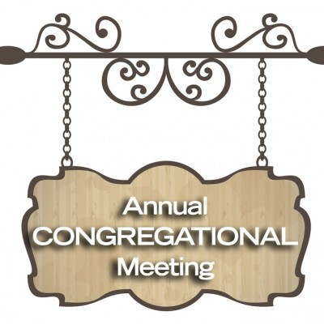

Sunday, January 26th

after Worship



The 2025 offering envelopes are on the counter in the annex. If you don’t see your name on a box and would like a box, please contact Laurie in the church office. **PLEASE DO NOT USE THESE UNTIL THE FIRST SUNDAY IN JANUARY** (JANUARY 5, 2025).



Sunday, January 26

after the Annual Meeting



February Epistle

articles are due

January 16th



14. Larry & Diane Montour

26. Jack & Diana Wurtinger



16. Gale Demlow

20. Terry Fuchs

22. James Wurtinger



(Members and Special Friends of the Church) Diane Montour; Ashley Wurtinger

(Family/friends of members) Pete Ballas; Donna Carlson; John & Jonelle Gregg; Stephanie Hackbarth; Ed Hilger; Molly Kapping; Bob Mackiewicz; Erik Olsen; and Jeff Reissmann

We pray for our military, especially Kassandra Derlein; Ben Glawoki; Padraic Kelly; and William Ryan Kelly for their protection and safe return, as well as healing for those who have been injured and are recovering.

We pray for the people suffering from the tragedies of war and for the people recovering from any natural disasters.