



The **EPISTLES OF FAITH**

**FAITH UNITED CHURCH OF CHRIST**

628 Clermont Street

Antigo, Wisconsin 54409

Phone: 715-623-5717

Church E-Mail Address: [faithucc@frontier.com](mailto:faithucc@frontier.com)

Rev. Dr. Wes A. Jedras: [wjedras@hotmail.com](mailto:wjedras@hotmail.com)

Church Website: [www.antigofaithucc.org](http://www.antigofaithucc.org)

**Administrative Assistant:** Laurie Hackbarth

**Church Office Hours:** Monday Closed;

Tuesday through Thursday 8:30 AM - 2:30 PM; Friday - Closed

**Church Council Chair:** Sue Moseman

**SUNDAY SCHEDULE**

**Worship:** 10:30 a.m.

***You are invited - Bring a friend!***

A

A



2025

**A Story from Pastor Wes:**

**A Surprise Test**

One day, a professor entered his classroom and asked his students to prepare for a surprise test. They all waited anxiously at their desks for the exam to begin.

The professor handed out the exams with the text facing down, as usual.

Once he handed them all out, he asked the students to turn over the papers.

To everyone’s surprise, there were no questions, just a black dot in the center of the paper. The professor, seeing the expression on everyone’s faces, told them the following: “I want you to write about what you see there.” The students, confused, got started on the inexplicable task.

At the end of the class, the professor took all the exams and started reading each one of them out loud in front of all the students.

All of them, with no exception, defined the black dot, trying to explain its position in the center of the sheet. After all had been read and the classroom fell silent, the professor started to explain:

“I’m not going to grade you on this, I just wanted to give you something to think about. No one wrote about the white part of the paper. Everyone focused on the black dot, and the same thing happens in our lives. We insist on focusing only on the black dot, the health issues that bother us, the lack of money, the complicated relationship with a family member, the disappointment with a friend. The dark spots are very small when compared to everything we have in our lives, but they are the ones that pollute our minds. Take your eyes away from the black dots in your lives. Enjoy each one of your blessings, each moment that life gives you. Be happy and live a life filled with love!”

Easter time allows us to reflect and to focus on the greatest blessing we have: Risen Christ reaching out to us.

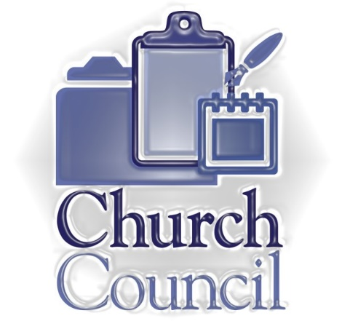

**Meeting**

**Sunday, February 16th**

Faith United Church of Christ’s 2024 Annual Report are available on the counter in the annex.



Sunday, February 16th



**February is Month**

During the month of February, you should look in your heart and do something for someone who would least expect it. It need not be costly or require a lot of time. It can just be a smile to a stranger or holding the door for someone. Maybe a card to a shut-in or a care package to a soldier. Offer to grocery shop for someone that is unable to. At the store, let someone waiting in line behind you take your place at the checkout register or at the coffee shop pay for the person behind you. Take a meal to someone who is sick or cook a meal for a family with a new baby. It could just be putting something straight that another has left messy. You could pick up the phone and call a friend or relative you have not talked to for a long time. The food pantry or humane society can always use supplies and volunteers. You decide what to do and when to do it and maybe just maybe it will put a smile on your face too.

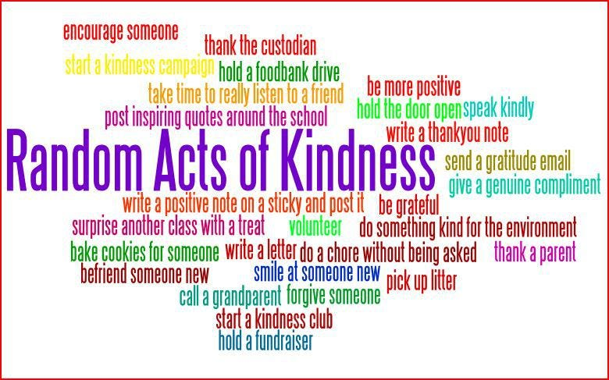



Pastor Wes will be on vacation Saturday, February 8th through Saturday, February 15th. For any pastoral emergencies please contact Jan Jones @715-253-3112.



Birthdays

6. Michelle Blahnik 15. Melissa Gallenberg

8. Mara Wurtinger 16. Derek Michno

14. Roy Gallenberg 19. Dennis Schroeder

15. Corey Andes



March Epistle

articles are due

February 13th.



(Members and Special Friends of the Church) Diane Montour; Ashley Wurtinger

(Family/friends of members) Pete Ballas; Donna Carlson; John & Jonelle Gregg; Stephanie Hackbarth; Ed Hilger; Bob Mackiewicz; Erik Olsen; and Tom Tveten

We pray for our military, especially Kassandra Derlein; Ben Glawoki; Padraic Kelly; and William Ryan Kelly for their protection and safe return, as well as healing for those who have been injured and are recovering.

We pray for the people suffering from the tragedies of war and for the people recovering from any natural disasters.



Every second Sunday of the month is designated as “Mission Sunday.” Instead of collecting for individual missions throughout the year, once a month we will have a general collection for OCWM and the four missions. One of the four missions is One Great Hour of Sharing. This mission supports partners worldwide with ministries that fund health, education and agricultural development, emergency relief, refugee ministries, and both international and domestic disaster response.

The work of the church, the body of Christ, is most profoundly demonstrated through mission outreach. Please give with generosity and compassion.