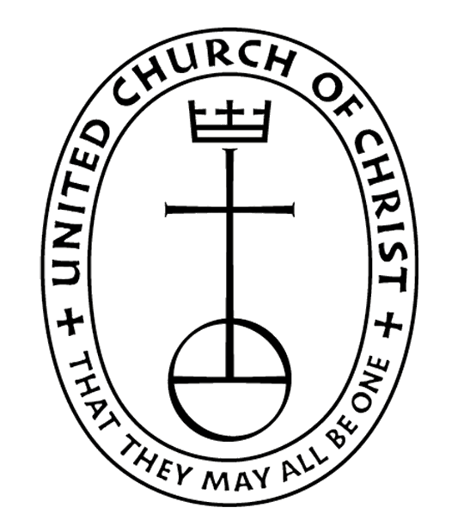

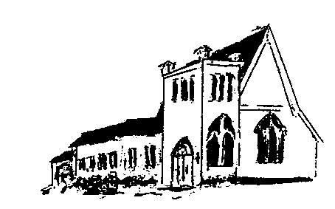

The **EPISTLES OF FAITH**

**FAITH UNITED CHURCH OF CHRIST**

628 Clermont Street

Antigo, Wisconsin 54409

Phone: 715-623-5717

Church E-Mail Address: [faithucc@frontier.com](mailto:faithucc@frontier.com)

Rev. Dr. Wes A. Jedras: [wjedras@hotmail.com](mailto:wjedras@hotmail.com)

Church Website: [www.antigofaithucc.org](http://www.antigofaithucc.org)

**Administrative Assistant:** Laurie Hackbarth

**Church Office Hours:** Monday Closed;

Tuesday through Thursday 8:30 AM - 2:30 PM; Friday - Closed

**Church Council Chair:** Sue Moseman

**SUNDAY SCHEDULE**

**Worship:** 10:30 a.m.

***You are invited - Bring a friend!***

A

A



November

2024

**A Story from Pastor Wes:**

**Miracles Happen – Brian Boyle true story**

They said that I was in God’s Hands because I was; I am living proof that miracles happen. My name is Brian Boyle, and this is my story.

A month after I graduated high school in 2004, I was coming home from swim practice and was involved in a near fatal car accident with a dump truck.

The impact of the crash violently ripped my heart across my chest, shattering my ribs/clavicle/pelvis, collapsing my lungs, damage to every single organ and failure of my kidneys and liver, removal of spleen and gallbladder, losing 60% of my blood, severe nerve damage to my left shoulder, and in a coma where I was on life support for over two months at Prince Georges Hospital Center in Cheverly, Maryland, USA.

I don’t have a memory of the accident, or the few days before the day of the accident. The first thing that I remember after the collision, which is still so vivid in my mind even today, is being in this very large white tube. In this tube was a boy sitting to my left, and many other boys and girls on my right side (I use the term “boys and girls” because they appeared to be my age); I didn’t know why I was there or how I even got there in the first place.

The more I sat there, the more I was able to visualize my surroundings. The boy to my left had a cell phone, and he asked me if I needed him to call anyone for me. I told him “yes, can you call my parents and tell them that I love them.” The next thing that I remember is waking up in a hospital bed, chemically paralyzed and hooked up to all these machines. Through all the buzzes and beeps going off from the medical equipment that was saving my life at that instant, I could hear my mom and dad telling me in between dramatic pauses of crying hysterically that I was going to be okay.

Only moments before, I believe I was waiting in line to meet my final judgment, but it must have not been my time. Moments later, I had come back to life. This was just the beginning of my suffering.

I died eight times while I was in the intensive care unit and even when I woke up from my coma, I couldn’t talk or communicate. The day that they knew that I would live was the day that I either left my room in a wheelchair or a body bag. As far as the future, it didn’t exist. Walking was never going to happen again due to all the extreme injuries and because of the shattered pelvis. The thought of swimming was just that, only a thought. Just like my body, my dreams were shattered. But I didn’t give up because I knew that God had a plan for me.

After spending two months in a coma, 14 operations, 36 blood transfusions, 13 plasma treatments, I lost a total of 100 pounds and had to go to a rehabilitation center in Baltimore. I had to learn how to talk, eat, walk, shower, and live independently again. After that agonizing experience, I had to go to outpatient therapy in Waldorf, MD. After spending a few months in a wheelchair, I took baby steps to walk on my own. It was a miracle that I could walk again, but I wanted to prove the doctors wrong and not only walk but run. After I accomplished that, I wanted to get back in the pool again. After a few lung tests, I was able to go in the pool a little bit each week.

Before the accident I had three goals: to go to college, swim on the team, and compete in an ironman triathlon one day. After a few months of swimming a few laps here and there with my training partner and good buddy, Sam Fleming, I decided that I was not going to let my injuries stop me from living my dream, and six months after that I began my freshman year at St. Mary’s College of Maryland and also was one of the swimmers to watch on the team. It’s very easy to go through and list these facts and make it look like everything just seemed to easily fall in its own perfect little place, but the truth of the matter is that it didn’t. It wasn’t easy, not then, and not now. The pain and the agony was real, and it existed all the way through, in the good times and the very bad. It was not an easy situation to be in where you’re lying in a bed, staring at the ceiling, knowing that your life is over while you’re looking at a priest give you the last rights. I thought to myself over and over, why this situation had to happen to me. I was always a good kid, received good grades in school, and went to church. Why would something as horrific as this happen to me? Why would God allow this? I went on and on for days asking why?

And, then it hit me. All that thinking and pondering on the what-if scenario’s and the questionable doubt only stirred up another question – why was I saved? I didn’t have any more questions after that. I know what my purpose in life finally is. With the 50 year life expectancy I was given from the doctors, I am just trying to live each day to the fullest and motivate and hopefully inspire other people, in their lives and in the faith. I have been labeled on several occasions that I am “Lazarus-like” because God brought me back to life. To inspire even more, I just successfully completed the Steelhead 70.3 half-ironman race in Michigan a few months ago and was also given the inspirational athlete media slot to compete in the 2007 Ford Ironman World Championship where my story and race footage was broadcasted in the Ironman show premiere as the main feature on NBC on

Dec. 1.

My story is about the recovery and the comeback, but I want to make it much more than that, I want to make a positive impact on the world. I am just trying to live each day to the fullest and motivate and hopefully inspire other people through my endeavors to never give up on their dreams, and to never stop believing in their faith in God no matter how bad a situation is because everything happens for a reason.

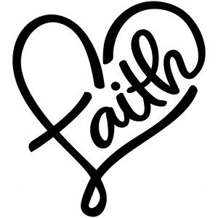



**Set your clocks back an hour**

**Sunday, November 3rd**



Sunday, November 24th



**Laurie will be on vacation Tuesday, November 5th through Thursday, November 7th. She will be back in the office on Tuesday, November 12th.**



December Epistle articles are due November 14th.

Church Council

Meeting

Sunday,

November 17th



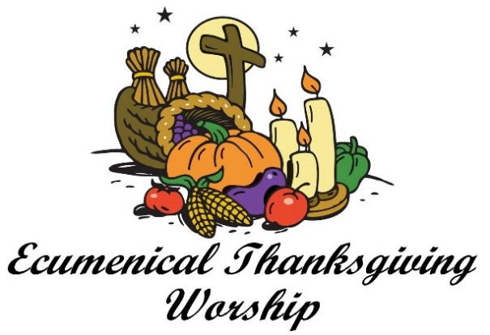

Wednesday, November 27th

7 p.m.

St. John’s Catholic Church

(Combined Choir practice @ 6 p.m.)



Hanging of the Greens

Sunday, November 24th

After the Potluck



Save the Date!!!

The Holiday Bazaar will be held on December 14th.



(Members and Special Friends of the Church) Alma Albrecht; Linda Bruss; The family of Tom McKinnon; Diane Montour; Ashley Wurtinger

(Family/friends of members) Pete Ballas; Chris Carlson; Donna Carlson; John & Jonelle Gregg; Stephanie Hackbarth; Ed Hilger; Beth Kelly; Kathy Krautkramer; Bob Mackiewicz; Jeff Reissmann; and Marguerite Wurtinger.

We pray for our military, especially Kassandra Derlein; Ben Glawoki; Padraic Kelly and William Ryan Kelly for their protection and safe return, as well as healing for those who have been injured and are recovering.

We pray for the people suffering from the tragedies of war and for the people recovering from any natural disasters.



**November**

**Anniversaries**

13. Pat & Lisa Prasalowicz 29. Dennis & Sally Schroeder



Birthdays

1. Florence Case 23. Kelly Derlein

3. Mike Blahnik 26. Padraic Kelly

6. Larry Montour 29. Linda Bruss

10. Laurie Hackbarth 29. Kassandra Derlein

11. Janet Larsen



A memorial has been received in memory of Donna Brettingen.