

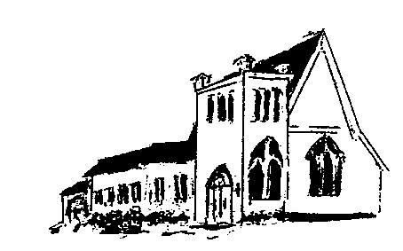

The **EPISTLES OF FAITH**

**FAITH UNITED CHURCH OF CHRIST**

628 Clermont Street

Antigo, Wisconsin 54409

Phone: 715-623-5717

Church E-Mail Address: [faithucc@frontier.com](mailto:faithucc@frontier.com)

Rev. Dr. Wes A. Jedras: [wjedras@hotmail.com](mailto:wjedras@hotmail.com)

Church Website: [www.antigofaithucc.org](http://www.antigofaithucc.org)

**Administrative Assistant:** Laurie Hackbarth

**Church Office Hours:** Monday Closed;

Tuesday through Thursday 8:30 AM - 2:30 PM; Friday - Closed

**Church Council Chair:** Sue Moseman

**SUNDAY SCHEDULE**

**Worship:** 10:30 a.m.

***You are invited - Bring a friend!***

A

A

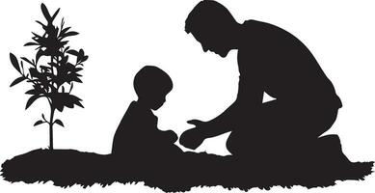

June

2024

**A Story from Pastor Wes:**

The Shoe Man Poem

My alarm went off

It was Sunday again.

I was sleepy and tired

My one day to sleep in.

But the guilt I would feel

The rest of the day

Would have been too much

So I'd go and I'd pray.

I showered and shaved

I adjusted my tie.

I got there and sat

In a pew just in time.

Bowing my head in prayer

As I closed my eyes.

I saw the shoe of the man next to me

Touching my own. I sighed.

With plenty of room on either side

I thought, "Why must our soles touch?"

It bothered me, his shoe touching mine

But it didn't bother him much.

A prayer began: "Our Father"...

I thought, "This man with the shoes

has no pride.

They're dusty, worn, and scratched

Even worse, there are holes on the side!"

"Thank You for blessings,"

the prayer went on.

The shoe man said

a quiet "Amen."

I tried to focus on the prayer

But my thoughts were on his shoes again.

Aren't we supposed to look our best

When walking through that door?

"Well, this certainly isn't it," I thought,

Glancing toward the floor.

Then the prayer was ended

And the songs of praise began.

The shoe man was certainly loud

Sounding proud as he sang.

His voice lifted the rafters

His hands were raised high.

The Lord could surely hear

The shoe man's voice from the sky.

It was time for the offering

And what I threw in was steep.

I watched as the shoe man reached

Into his pockets so deep.

I saw what was pulled out

What the shoe man put in.

Then I heard a soft "clink"

as when silver hits tin.

The sermon really bored me

To tears, and that's no lie

It was the same for the shoe man

For tears fell from his eyes.

At the end of the service

As is the custom here

We must greet new visitors

And show them all good cheer.

But I felt moved somehow

And wanted to meet the shoe man

So after the closing prayer

I reached over and shook his hand.

He was old and his skin was dark

And his hair was truly a mess

But I thanked him for coming

For being our guest.

He said, "My names' Charlie

I'm glad to meet you, my friend."

There were tears in his eyes

But he had a large, wide grin

"Let me explain," he said

Wiping tears from his eyes.

"I've been coming here for months

And you're the first to say 'Hi.'"

"I know that my appearance

Is not like all the rest

"But I really do try

To always look my best.

"I always clean and polish my shoes

Before my very long walk.

"But by the time I get here

They're dirty and dusty, like chalk."

My heart filled with pain

and I swallowed to hide my tears

As he continued to apologize

For daring to sit so near.

He said, "When I get here

I know I must look a sight.

"But I thought if I could touch you

Then maybe our souls might unite."

I was silent for a moment

Knowing whatever was said

Would pale in comparison

I spoke from my heart, not my head.

"Oh, you've touched me," I said,

"And taught me, in part;

"That the best of any man

Is what is found in his heart."

The rest, I thought,

This shoe man will never know.

Like just how thankful I really am

That his dirty old shoe touched my soul.

- Leanne Freiberg



**June**

2. Lindsey Beck

9.

16. Delores Kohler

23.

30. Lou Ann Tousey



Birthdays

19. Diana Wurtinger

20. Randy Griffin

24. Mary Fuchs

25. Dan Hilger

28. Tom Fuchs

30. Diane Montour



15. Tom & Lolita McKinnon

26. Elon & Florence Case

30. Randy & Mary Griffin



Prayer Requests

(Members and Special Friends of the Church) Alma Albrecht; Kelly Derlein; Tom McKinnon; Diane Montour; Ashley Wurtinger

(Family/friends of members) Pete Ballas; Chris Carlson; Donna Carlson; John & Jonelle Gregg; Ed Hilger; Bob Mackiewicz; Lolly Olsen; and Jeff Reissmann

We pray for our military, especially Kassandra Derlein; Ben Glawoki; Padraic Kelly and William Ryan Kelly for their protection and safe return, as well as healing for those who have been injured and are recovering.

We pray for the people suffering from the tragedies of war and for the people recovering from any natural disasters.



**The Wisconsin Conference UCC supports and strengthens the faithful ministry of congregations throughout our state. The Wisconsin Conference can do this because of our gifts to OCWM Basic Support.**

The Wisconsin Conference organizes programs like Youth Faith Formation Ret. Youths loved the opportunity to gather again at the beautiful Daycholah Center of United Church Camps, Inc.

A retreat in March focused on “Journeys of Faith.” Young people creatively explored biblical stories of people who made journeys, then engaged in spiritual practices to help explore their personal faith journeys. “The ‘Letting Go’ prayer station was meaningful,” one youth said.  “I could really feel it when I held the rocks and thought about all the stress and burdens I hold on to.  It felt good to let those go.”

Time spent with members their own congregations allowed youths to go more deeply into their own stories. “I think I need to forgive God before I can go any further with this,” one said.

Many participants came from congregations with few other young people. The retreat connected them with peers. “I made new friends,” one person said.  “It felt good to be here with a large group of kids.”

The Rev. Julie Eklund saw the impact of the retreat on participants from her congregation. “Our confirmation class had just completed our Spiritual Practices Class the week before we left for camp,” Julie said. “They really connected what they learned with the activities and opportunities at camp. The Spirit moves!”

**Our gifts to OCWM Basic Support make an impact on congregations throughout Wisconsin through programs like the Youth Faith Formation Retreats. By working together, we can provide meaningful and engaging programs that best serve all our congregations.**