

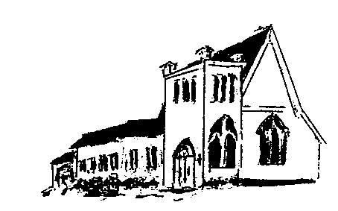

The **EPISTLES OF FAITH**

**FAITH UNITED CHURCH OF CHRIST**

628 Clermont Street

Antigo, Wisconsin 54409

Phone: 715-623-5717

Church E-Mail Address: [faithucc@frontier.com](mailto:faithucc@frontier.com)

Rev. Dr. Wes A. Jedras: [wjedras@hotmail.com](mailto:wjedras@hotmail.com)

Church Website: [www.antigofaithucc.org](http://www.antigofaithucc.org)

**Administrative Assistant:** Laurie Hackbarth

**Church Office Hours:** Monday Closed;

Tuesday through Thursday 8:30 AM - 2:30 PM; Friday - Closed

**Church Council Chair:** Sue Moseman

**SUNDAY SCHEDULE**

**Worship:** 10:30 a.m.

***You are invited - Bring a friend!***

A

A



2024

**A Story from Pastor Wes:**

Story on Peace

There once lived a very wealthy man who was willing to pay a small fortune to the artist who could best illustrate the presence of peace. Several artists brought paintings of sunsets and quiet meadows, but the man did not accept any of these. One day as he was walking through looking at the most recent attempts, two paintings captured his attention.

One was a painting of a beautiful calm lake surrounded by lush green mountains. The water seemed as still as glass and wispy white clouds danced in the bright blue of the sky. Next to this painting was another with vast differences. It was also a picture of a lake surrounded by mountains, but the strong winds had whipped the lake into a tempest and the dark clouds hovered about the rugged mountain landscape ready to release a downpour of torrential rains.

The audience standing about watched with anticipation to see which one the man might choose to depict the story of peace. All were shocked when he did not choose the first, but instead chose the second. How could such a stormy scene tell a story of peace?

The rich man explained. The first painting was beautiful and peaceful, but it didn’t tell the truth of where peace can be found. Anyone could feel peaceful upon a crystal-clear lake with white clouds drifting across the sky and barely a breeze blowing across the water.

Then he pointed out something in the second painting which everyone else had overlooked. If you peered closely into the mountains of the second, there was a waterfall, and tucked into a crevice of that mountain near the waterfall was a small nest on which a mother bird sat upon tiny blue eggs.

The man spoke. “This second painting is a picture of true, perfect peace because it is within the storms of life we find real peace tucked into the side of God knowing His presence will guard and protect us even in the midst of this world’s storms.”



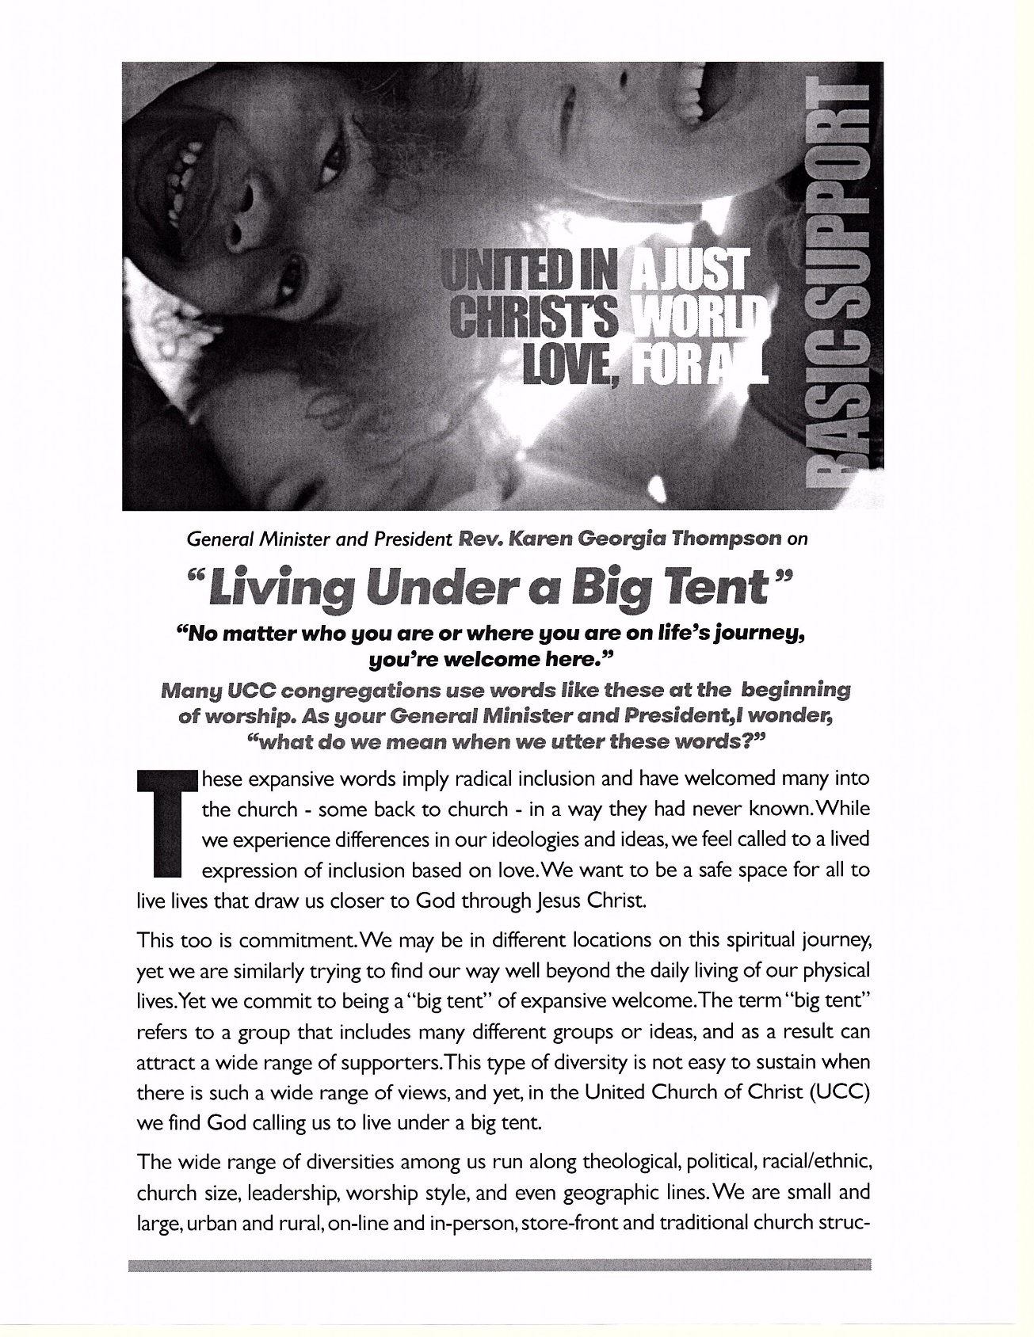

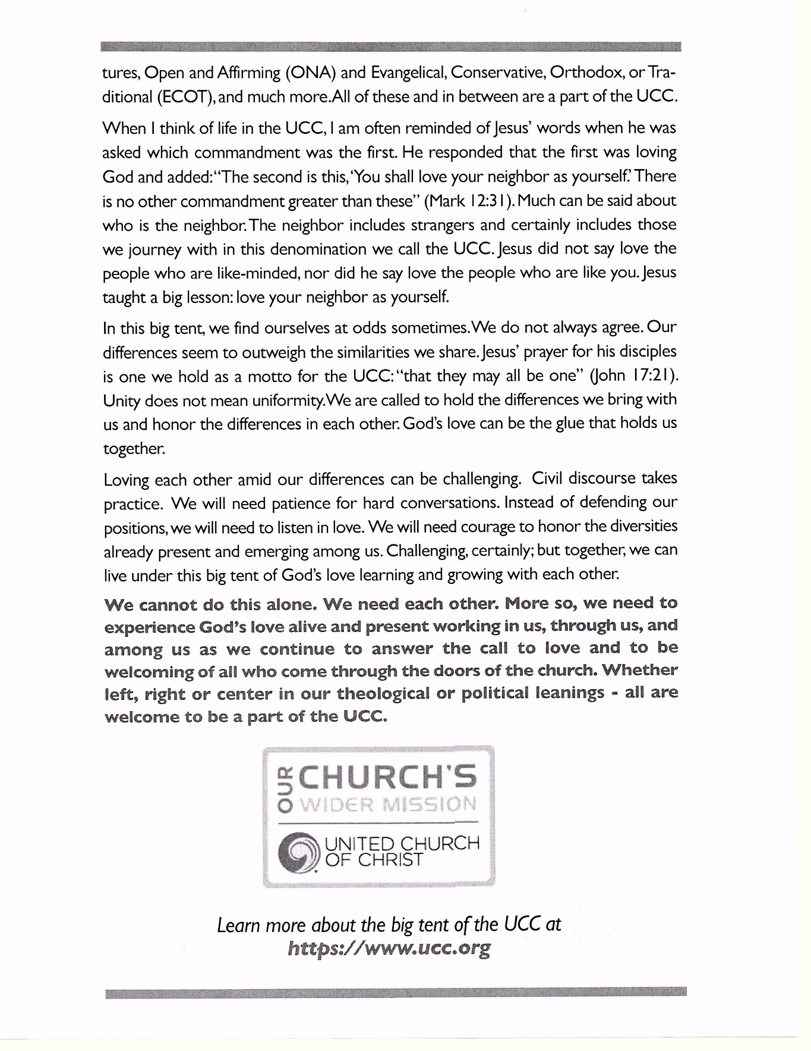



Pastor Wes will be on vacation August 5th through August 29th. For any pastoral emergencies, please contact Jan Jones @ 715-253-3112.



4. Ryan Gallenberg

15. Arlene Schuh



6. Dan & Patti Hilger

7. Ron & Sue Moseman



(Members and Special Friends of the Church) Alma Albrecht; Tom McKinnon; Diane Montour; Ashley Wurtinger

(Family/friends of members) Pete Ballas; Chris Carlson; Donna Carlson; John & Jonelle Gregg; Ed Hilger; Bob Mackiewicz; Jeff Reissmann; and Marguerite Wurtinger.

We pray for our military, especially Kassandra Derlein; Ben Glawoki; Padraic Kelly and William Ryan Kelly for their protection and safe return, as well as healing for those who have been injured and are recovering.

We pray for the people suffering from the tragedies of war and for the people recovering from any natural disasters.



