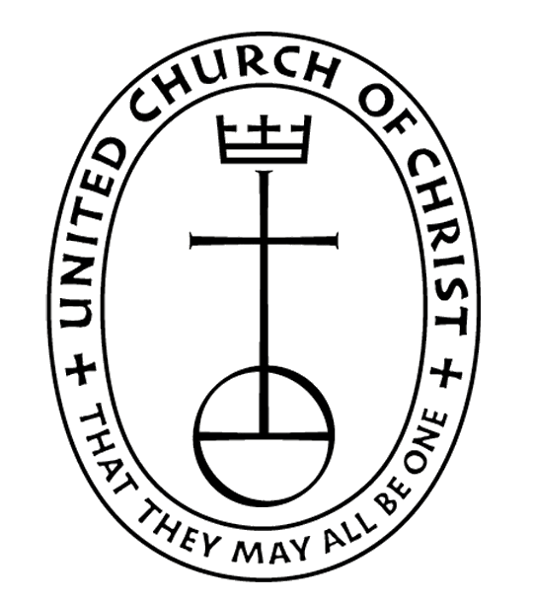
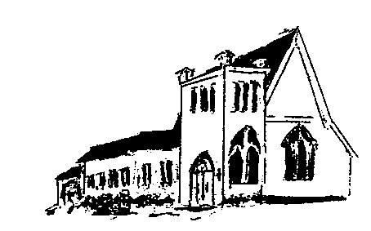

The EPISTLES OF FAITH

FAITH UNITED CHURCH OF CHRIST
628 Clermont Street
Antigo, Wisconsin 54409
Phone: 715-623-5717
Church E-Mail Address: faithucc@frontier.com
Rev. Dr. Wes A. Jedras: wjedras@hotmail.com
Church Website: www.antigofaithucc.org
Administrative Assistant: Laurie Hackbarth
Church Office Hours: Monday Closed;
Tuesday through Thursday 8:30 AM - 2:30 PM; Friday - Closed
Church Council Chair: Sue Moseman

SUNDAY SCHEDULE
Worship: 10:30 a.m.

You are invited - Bring a friend!

A

A

2024
A Story from Pastor Wes:

A Story on Peace

There once lived a very wealthy man who was willing to pay a small fortune to the artist who could best illustrate the presence of peace. Several artists brought paintings of sunsets and quiet meadows, but the man did not accept any of these. One day as he was walking through looking at the most recent attempts, two paintings captured his attention.

One was a painting of a beautiful calm lake surrounded by lush green mountains. The water seemed as still as glass and wispy white clouds danced in the bright blue of the sky. Next to this painting was another with vast differences. It was also a picture of a lake surrounded by mountains, but the strong winds had whipped the lake into a tempest and the dark clouds hovered about the rugged mountain landscape ready to release a downpour of torrential rains.

The audience standing about watched with anticipation to see which one the man might choose to depict the story of peace. All were shocked when he did not choose the first, but instead chose the second. How could such a stormy scene tell a story of peace?

The rich man explained. The first painting was beautiful and peaceful, but it didn’t tell the truth of where peace can be found. Anyone could feel peaceful upon a crystal-clear lake with white clouds drifting across the sky and barely a breeze blowing across the water.

Then he pointed out something in the second painting which everyone else had overlooked. If you peered closely into the mountains of the second, there was a waterfall, and tucked into a crevice of that mountain near the waterfall was a small nest on which a mother bird sat upon tiny blue eggs.

The man spoke. “This second painting is a picture of true, perfect peace because it is within the storms of life we find real peace tucked into the side of God knowing His presence will guard and protect us even in the midst of this world’s storms.”

Sunday, January 7th

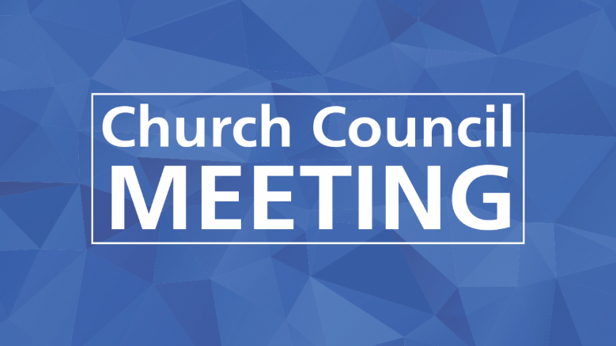
Sunday, January 7th

Committee Chairs or anyone else that needs to submit a report to be included in the 2023 Annual Report, please have them submitted to the church office on Sunday, January 7, 2024. Thank you.

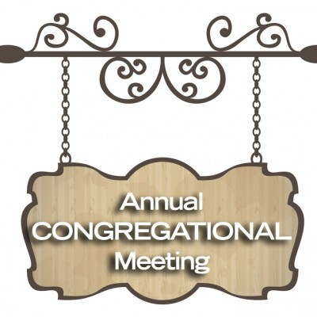
Sunday, January 21st
after Worship

The 2024 offering envelopes are on the counter in the annex. If you don’t see your name on a box and would like a box, please contact Laurie in the church office. PLEASE DO NOT USE THESE UNTIL THE FIRST SUNDAY IN JANUARY (JANUARY 7, 2024).

Sunday, January 21st
after the Annual Meeting

February Epistle
articles are due
January 18th

Thank you to everyone who contributed and or helped with the Christmas Bazaar in any way. We had a great day! The final total after selling items on Sunday was $2,573 and the left-over pie pieces were taken over the to the fire station, which they really appreciated.

14. Larry & Diane Montour
26. Jack & Diana Wurtinger

16. Gale Demlow
20. Terry Fuchs
22. James Wurtinger

(Members and Special Friends of the Church) Herman Albrecht; Kelly Derlein; Tom McKinnon; Diane Montour; Ashley Wurtinger

(Family/friends of members) Pete Ballas; Chris Carlson; Donna Carlson; Ed Hilger; and Bob Mackiewicz

We pray for our military, especially Kassandra Derlein; Ben Glawoki; Padraic Kelly and William Ryan Kelly for their protection and safe return, as well as healing for those who have been injured and are recovering.

We pray for the people suffering from the tragedies of war and for the people recovering from any natural disasters.

