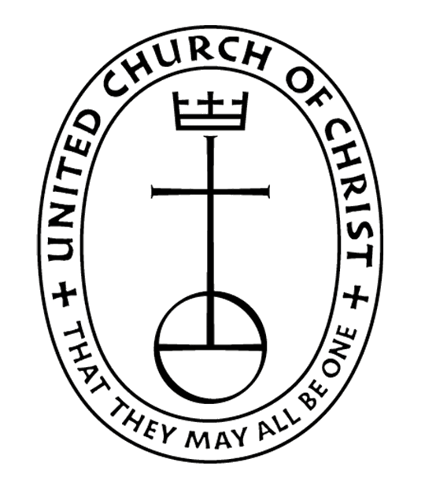
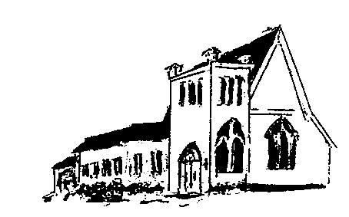

The EPISTLES OF FAITH

FAITH UNITED CHURCH OF CHRIST
628 Clermont Street
Antigo, Wisconsin 54409
Phone: 715-623-5717
Church E-Mail Address: faithucc@frontier.com
Rev. Dr. Wes A. Jedras: wjedras@hotmail.com
Church Website: www.antigofaithucc.org
Administrative Assistant: Laurie Hackbarth
Church Office Hours: Monday Closed;
Tuesday through Thursday 8:30 AM - 2:30 PM; Friday - Closed
Church Council Chair: Sue Moseman

SUNDAY SCHEDULE
Worship: 10:30 a.m.

You are invited - Bring a friend!

A

A

2024
A Story from Pastor Wes:

Potatoes, Eggs, and Coffee Beans
Once upon a time a daughter complained to her father that her life was miserable and that she didn’t know how she was going to make it. She was tired of fighting and struggling all the time. It seemed just as one problem was solved, another one soon followed.
Her father, a chef, took her to the kitchen. He filled three pots with water and placed each on a high fire. Once the three pots began to boil, he placed potatoes in one pot, eggs in the second pot, and ground coffee beans in the third pot.
He then let them sit and boil, without saying a word to his daughter. The daughter, moaned and impatiently waited, wondering what he was doing.
After twenty minutes he turned off the burners. He took the potatoes out of the pot and placed them in a bowl. He pulled the eggs out and placed them in a bowl.
He then ladled the coffee out and placed it in a cup. Turning to her he asked. “Daughter, what do you see?”
“Potatoes, eggs, and coffee,” she hastily replied.
“Look closer,” he said, “and touch the potatoes.” She did and noted that they were soft. He then asked her to take an egg and break it. After pulling off the shell, she observed the hard-boiled egg. Finally, he asked her to sip the coffee. Its rich aroma brought a smile to her face.
“Father, what does this mean?” she asked.
He then explained that the potatoes, the eggs and coffee beans had each faced the same adversity– the boiling water.
However, each one reacted differently.
The potato went in strong, hard, and unrelenting, but in boiling water, it became soft and weak.
The egg was fragile, with the thin outer shell protecting its liquid interior until it was put in the boiling water. Then the inside of the egg became hard.
However, the ground coffee beans were unique. After they were exposed to the boiling water, they changed the water and created something new.
“Which are you,” he asked his daughter. “When adversity knocks on your door, how do you respond? Are you a potato, an egg, or a coffee bean? “

Moral: In life, things happen around us, things happen to us, but the only thing that truly matters is what happens within us. Which one are you?

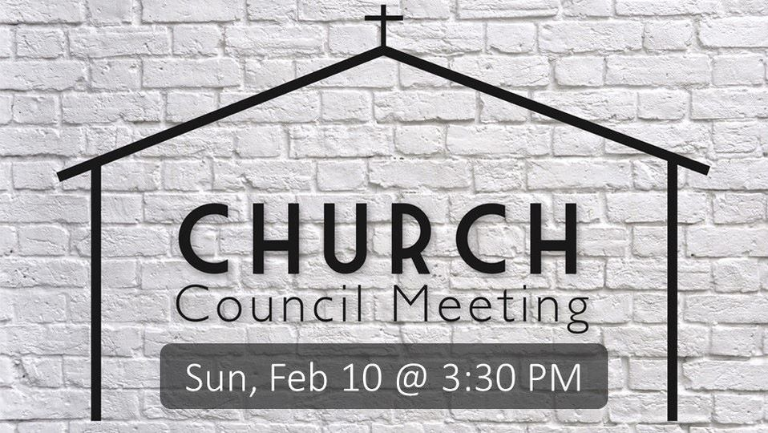

Sunday, May 19th

Sunday, May 26th
This will be the last potluck until Fall.

It’s that time of the year again. Faith United Church will be holding their annual brat, hamburger, and pie sale on May 24th from 10 a.m. to 1 p.m. This will be our only pie sale for the summer, as Lakeside has prebooked all the other summer dates.

We are asking for many workers to bring tables and chairs from the church at around 8 a.m. At the sale we will need cooks, sales people, and clean-up.

Of courses, all members are asked to bake many of those beautiful pies. We, hopefully, will have many ladies to cut and serve pies. Please have the pies to Lakeside by 9 a.m. on Friday morning.

Thanking you in advance. I wish to let you know that we have always had a super sale and I know with your help this can be another.

Can’t bake, we always accept cash donations. Come on down have lunch and share our friendship.

God Bless,
Sue Moseman
Council Chair

Birthdays

4. Arlene King 16. Larry Noskowiak
5. Lolita McKinnon 17. Sally Schroeder
9. Owen Andes 26. Jack Wurtinger Jr.
12. Tom McKinnon 29. Karissa Derlein
12. Sara Rasmussen

May
Anniversaries

May
7. Steve & Lynn Fermanich
11. Matt & Sara Rasmussen

Every second Sunday of the month (May 12th) is designated as “Mission Sunday.” Instead of collecting for individual missions throughout the year, once a month we will have a general collection for OCWM and the four missions.
One of the four missions is Strengthen the Church. The Strengthen the Church Offering reflects the commitment of all settings of the United Church of Christ to cooperatively build up the UCC. The funds raised support leadership development, new churches, youth ministry, and innovation in existing congregations as we work to become a multi-cultural/multi-racial, accessible to all Christian movement.
The work of the church, the body of Christ, is most profoundly demonstrated through mission outreach. Please give with generosity and compassion. (If you prefer to give to a specific mission, please put your contribution in an envelope and mark the envelope with your selection.)

(Members and Special Friends of the Church) Alma Albrecht; Kelly Derlein; Tom McKinnon; Diane Montour; Ashley Wurtinger

(Family/friends of members) Pete Ballas; Chris Carlson; Donna Carlson; John & Jonelle Gregg; Ed Hilger; Bob Mackiewicz; and Lolly Olsen

We pray for our military, especially Kassandra Derlein; Ben Glawoki; Padraic Kelly and William Ryan Kelly for their protection and safe return, as well as healing for those who have been injured and are recovering.

We pray for the people suffering from the tragedies of war and for the people recovering from any natural disasters.

Please contact the church office by calling at 715-623-5717 or e-mailing faithucc@frontier.com if you have a son or daughter that is graduating from high school or college.

